Template information document and consent form
Ethics Committee Social Sciences
Version 1.0 November 2025
Instructions
1. Use the document below to create an information document for participants over 16 years of age. Carefully review which sections apply to your study and add or adjust details as needed.
2. Please note the following when adjusting the document:
- Optional sections are highlighted in yellow—only include them if applicable.
- [Square-bracketed text] are instructions or placeholders for you to fill in or to make a choice. Adjust this text to fit your study.
3. Delete the following from the final version of your document:
- This page and the next (researcher guidance)
- All [square-bracketed] text
- Any unused optional sections
4. The aim of the information document is to clearly inform participants (and/or their representatives) so they can make a well-informed decision on whether or not to participate in the research. It is therefore important that you adjust the language in the document to the target group. Use accessible language and avoid jargon.
5. In addition to providing information about and requesting consent for participation in the study, the information letter and consent form also aim to fully inform the participant about, and request consent for, the processing of his/her personal data. If you collect (special categories of) personal data, you should mention this in the information document. Make sure that the personal data mentioned in the information document match the personal data that are included in your Data Management Plan and consent form.
Personal data are any information that can be traced to an individual either directly, indirectly or in combination with other data. Examples include: name, date of birth, address, postcode, email address and IP address.
Demographic and language data (such as age, sex/gender, education level, profession and native language) can be personal data, but this is not always the case. They are considered personal data if they can be linked to an individual directly or in combination with other data (i.e., if you know or could find out who the data refers to). Age and gender can for instance be traced to an individual (and thus be personal data) if you are investigating a very rare group, of which there are only a few individuals in the Netherlands.
Special categories of personal data are those whose processing may infringe on someone’s privacy. Examples include: health data (e.g., illness/disability/BMI), ethnic origin (race), political opinions, religion, union membership, sexual orientation, genetic (e.g., DNA) and biometric data used for uniquely identifying an individual (e.g., fingerprint, voice, handwriting).
Sensitive personal data include: citizen service numbers (BSN), (job) performance evaluations, financial information, criminal convictions and offenses. Also these data are only considered personal data if they can be traced to an individual directly, indirectly or in combination with other data.

For questions about personal data, please contact the local privacy officers (privacy.fsw@ru.nl).

6. If you collect more than 2 types of personal data, you should present this in a table. In this table, you should describe the following:
• type of personal data
• why you collect this data (purpose)
• how you store the data
• how long you retain the data
• whether you share the data after the research.
On the informed consent page of the ECSS website you can find more instructions for and examples of this table. If your table contains only 1 or 2 rows, because you collect little or no personal data, you may also choose to mention this in the text of the information document instead of using the table.
7. If personal data or non-anonymous research data are shared with an organisation in a ‘third country’ (outside the European Economic Area) and that country is not covered by an adequacy decision, contact the local privacy officers (privacy.fsw@ru.nl). In that case participants need to be informed about additional privacy measures. Please note: if you share data via a repository, the data may also be accessible to ‘third countries’. See also the guidelines for sharing directly identifiable data: https://data.ru.nl/doc/help/helppages/best-practices/bp-selecting-dua.html. Directly identifiable data should be shared restrictedly in a repository.
8. The consent form in this template applies in cases where consent is recorded on paper. If the study is conducted online, consent may be obtained by means of a checkbox (with a timestamp) that the participant must actively click, instead of a signed form with a handwritten signature.
9. For research with SONA participants, please note the following on sharing information on the research with participants. You should provide the study information well in advance to your participants. Unfortunately, it is not possible to send attachments via the SONA Participant system. Therefore, we recommend you to put your information document(s) on Surfdrive and to create a public link. Here you find the step-by-step manual on how to create a public link. You must share this direct link with your participant via the Direct Message option of SONA.
10. If, prior to the start of the study, the participant cannot be fully informed about the research topic, provide a general description and ensure that the participant is fully informed by the end of the study (debriefing). During the debriefing, the participant may also be asked again whether they still consent to the use of their data now that they are aware of the deception.
11. For some methods additional method information is required. This pertains to the following methods: EEG, robot arm, sled; and (still under construction) TUS, TMS, TES, MRI. You can find these forms on the informed consent page of the ECSS website. Please share this information together with the general information with your participants before the experiment (usually >24 hours)
12. Sometimes it is important for safety or data quality to do an additional screening before the experiments. This screening is required for the following research types: EEG, sled; and (still under construction) TUS/TMS/TES, MRI and you can find these forms on the informed consent page of the ECSS website.
13. Keep the footer with the date and version number. You do not need to add anything else here.



INFORMATION ABOUT THE RESEARCH
[insert short and clear title, matching the title in the consent form]

Introduction
We invite you to participate in a scientific study conducted by Radboud University. Before you decide whether to participate, you will receive information about the study (described below). Please read the following information carefully.

Who is conducting the study?
This study is conducted by [name and position/department of the researcher(s)].
[For student research: include student’s name, study program at the Radboud University and supervisor’s name.]
[If collaborating with other universities or organizations: include the names of the collaborating individuals and organisations.]

What are we investigating?
[Briefly describe the subject and the purpose of the study. Explain its scientific and/or societal relevance. Please note: use clear, non-technical language.]
What does participation involve?
In this study you will [give a simple (avoid jargon!) and clear explanation of what the participant will do, how much time is required, where the study takes place, etc.].

[For research taking place in the Maria Montessori Building, add the following information:]
The study will take place in the Maria Montessori Building. You can take a seat in room 01.302 (see also Appendix A for further information). The researcher will come to meet you there and guide you to the room where the experiment will be conducted. In that room, the researcher will explain the purpose of the study, describe what is expected of you, and explain how everything will proceed.

Compensation
[Describe the compensation or benefit for the participant (e.g., course credit, gift voucher, as well as knowledge gained, feedback, or contribution to science). Please note the following points:
- The compensation or benefit must be proportional to the effort or burden placed on the participant and consistent with the compensation or benefits offered in other comparable studies. According to the ECSW guidelines, the maximum compensation is €15 per hour or 1 course credit per hour. See here for DCC-specific guidelines and here for BSI-specific guidelines.
- If participants do not complete the study or fail to attend all sessions, the compensation must be paid proportionally.
- If a lottery is held among participants, the odds (e.g., total number and value of vouchers to be distributed) must be clearly stated.
- In case compensation is provided, specify how it will be paid (e.g., via bank transfer, VVV card, online bol.com voucher, etc.).]

[The text below is an example for a study lasting one and a half hours, in which participants receive 15 euros per hour or course credit:]
As a thank-you for your participation, you will receive a compensation of 22.50 euros in online VVV gift cards or 1.5 participant hours (ppu).

[The text below is an example for a study including attention checks to ensure participants complete the tasks properly:]
Because this study is conducted online, we will check whether you have completed all tasks correctly. We may also include additional questions to see if you paid close attention. If it turns out that you did not follow the instructions properly, you may not receive a reward.

Risks and inconvenience
This study may involve risks or discomfort. It concerns [describe possible risks or discomfort for the participant].

Who should not participate?
[Describe groups of people who are advised not to participate in this research due to increased risk or discomfort.]

What data will we collect and how will the data be handled?
During the study we will only collect data necessary to answer the research question. We comply with the General Data Protection Regulation (GDPR).

The table below outlines what data we collect, how the data will be used and stored, and who will have access. Your data will be securely stored according to the guidelines of Radboud University.

[Insert the table here. If your table contains only one or two rows because you collect little or no personal data, you may instead choose to describe this information in the main text rather than using a table. See the document on the informed consent page on the ECSS website for detailed instructions and examples of the table.]

[If the table is not used, but audio and/or video recordings are made during the study, include the yellow highlighted text below (make sure to select the parts that apply to your study). These texts can be deleted if the recordings are already mentioned in the table:]
In this study, [choose: video recordings/audio recordings/photographs] will be made.
[Example text for transcription, after which the recording is deleted:]
The audio recordings will be transcribed, and the transcribed text will be used for our analysis. Identifiable information, such as names, will be removed from the text. After this, the original recordings will be destroyed.
[Example text for cases where the recording is not deleted after transcription. Remove any sentences that do not apply to your study:]
The original recordings will be stored for at least 10 years, in accordance with the guidelines of Radboud University. These original recordings will not be shared with others unless you give explicit permission. The recordings will also only be used in teaching (such as lectures or seminars) and/or other presentations of the research if you have given explicit permission for this. On the consent form, you can indicate what you do and do not consent to.
Sharing of research data
We may share your research data so others can view or use the data. Before sharing, we will anonymise the data as much as possible. Anonymous means that the data are not traceable to you. Here we explain how and why we may share research data.
[Only add this sentence if you are collecting (potentially) identifiable data.]
Non-anonymous data will only be shared with others outside the research team if you give explicit permission on the consent form.

[If all the data you collect to answer the research question are anonymous, use this text instead of the text above:]
It is possible that we will share your anonymous data with others so that they can review or understand the data. Here we explain how and why we would like to share the research data.

Unexpected findings
[In research where incidental findings are not possible and not expected to be found, this section can be omitted. In the three cases below information needs to be provided. Choose one of the following if relevant:]

- [MRI or similar studies with potential incidental findings:]
Your research data will not be assessed for medically or clinically relevant information. Participation in this study is therefore not a medical or clinical test. On rare occasions, we may find something that could be important for your health. Follow-up research by a doctor or expert may then be necessary. If this happens, the research center will inform you. A referral to a doctor in a hospital may incur costs, for example, your health insurance deductible. If you do not want to receive this information, unfortunately, you cannot participate in the study.
- [EEG/questionnaire studies where participants might expect findings:]
Your research data will not be assessed for clinically or medically relevant information. Participating in this study is therefore not a clinical or medical test. If you have health concerns, please contact your [specify, for example: general practitioner, student psychologist].
- [Anonymous studies with potential incidental findings:]
As this study is completely anonymous, we cannot provide feedback on potentially concerning results. If you feel worried after answering the questions, we recommend contacting your [specify, for example: general practitioner, student psychologist].

Voluntary participation
Participation in this study is voluntary. You may stop participating in the study at any time and withdraw your consent. You do not need to provide a reason for stopping. If you choose to stop, we will delete your data unless you indicate otherwise

Consent to use your data
Your data will only be used for this study with your consent. You can withdraw consent later, even after participation, by emailing [researcher's email]. Please note: in some cases, data may not be deleted. If you want to know more, see here for more information.

Future research
[Please note: future research differs from follow-up studies. Follow-up studies take place within one month after finishing the study and are directly related to your own research. Future research refers to you or a colleague approaching participants for a new study, for instance because they are part of a specific population. If you want to approach participants for future research, you should use the text below].

We may contact you in the future about another study. If you consent, the research institute will store your contact details (name, email) for [specify duration, max. 2 years].

Do you have questions?
If you have questions or would like more information about the study, please contact [name, email, and phone number if applicable].
For questions about the processing of your data in this study, please contact privacy.fsw@ru.nl.
More information on how your data is protected and who has access can be found on this website.
Ethical review and feedback
This study has received a positive evaluation by the Ethics Committee Social Sciences. If you have feedback about the study, please contact the researcher.
[For BSI research add the following information:]
We are curious about your experience with this study at the Behavioral Science Institute. You can fill in a short questionnaire online. You can do this anonymously if you prefer. The questionnaire is available in Dutch and in English.
Do you have questions, comments, or concerns that you would rather not discuss with the researcher? Then you can contact the BSI Research Data Officer at dataofficer@bsi.nl. This person is an independent contact for research and is not involved in this study
[For DCC research add the following information:]
We are curious about your experience with this study at the Donders Centre for Cognition. You can fill in a short questionnaire online. You can do this anonymously if you prefer. The questionnaire is available in. Dutch and English.
Do you have questions, comments, or concerns that you would rather not discuss with the researcher? Then you can contact the DCC research integrity officer at dcc-researchintegrity-officer@donders.ru.nl. This person is an independent contact for research and is not involved in this study.

Kind regards,
[researcher name]
[researcher email and/or phone number]
[For student research, also include:
Radboud supervisor’s name
Radboud supervisor’s email]

Appendix A Route Maria Montessori building
Maria Montessori building
Radboud University
Thomas van Aquinostraat 4
6525 GD Nijmegen

To reach waiting room 01.302, you can follow the path indicated below.

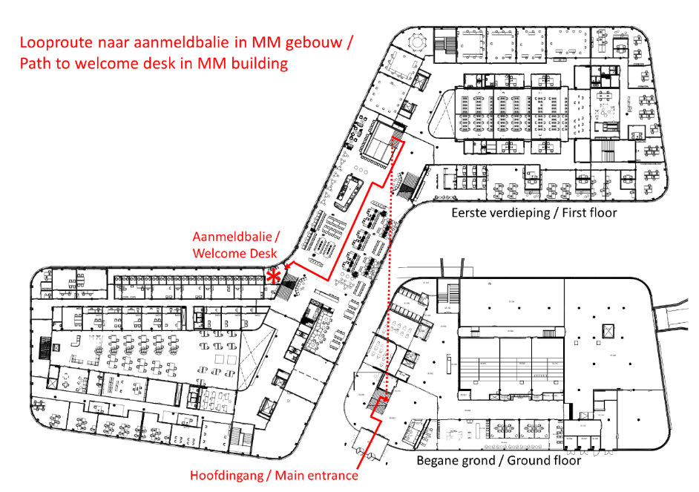

CONSENT FORM
for participation in the study: [insert short and clear title, matching the title in the information document]
Participant Statement:
- I have read the information document about the study;
- I have had the opportunity to ask questions about the study;
- I am participating in the study voluntarily;
- I understand that [specify: video recordings/audio recordings/photos] will be made of me;
- I understand that I may withdraw from the study at any time;
- I understand how the data from the study will be used, shared and stored;
[Include the following line only if applicable, see the information document for guidance]
- I understand that my research data will not be reviewed for medically or clinically relevant information;
- I understand that I have the right to withdraw my consent for the use of my data. The information document explains how I can do this;
- I agree to participate in the study as described in the information document.

[The boxes below are optional. Use them only if they are relevant to your study. Remove any options that do not apply.
First box: If applicable, it is mandatory that participants give consent for the processing of their (special) personal data (unless the study is truly fully anonymous) and that researchers can contact them in case of incidental findings (if there is a chance of incidental findings that will be communicated).
Second box: This box contains options for which consent is not required to participate in the study. Participants can answer “no” here without it affecting their ability to take part.]

I give permission for the following (please tick the boxes that apply):
Yes No (If you answer “no,” you cannot participate in this study.)

¨ ¨ The collection, use, storage and sharing of my personal data as described in the information document.

[in the case of incidental findings that are communicated back, remove if not applicable:]
¨ ¨ To be contacted if unexpected results from the study emerge that may be important for my health.

Additionally, I give permission to (please tick the boxes that apply):
Yes No (Your answers to these statements do not determine whether you can participate. You can answer “no” to these statements and still take part in the study.)
¨ ¨ Use the [video recordings/audio recordings/photos] in which I can be [seen/heard] for other research.
¨ ¨ Use the [video recordings/audio recordings/photos] in which I can be [seen/heard] for educational purposes (e.g., in a lecture or class) and/or other presentations of the research (e.g., at a conference).
¨ ¨ Use the [video recordings/audio recordings/photos] in which I can be [seen/heard] in a publicly accessible report on the internet.
¨ ¨ Store my contact details for a period of [specify duration] so the research institute can contact me for future research.
I agree to participate in the study as described in the information document and I give my consent for the statements above to which I have answered ‘yes.’

Name: …………………………………………………………......……………………………………………………………………………..
Signature: ......................................................... Date: ………………………………..................................

Researcher Statement
The undersigned declares that the person mentioned above has been informed about the research described above.
Name: …………………………………………………………......……………………………………………………………………………..
Function / research institute : ………………………......……………………………………………………………………………
Signature: ......................................................... Date: ……………………………….................................

[In the case of DCC research, use the following statement instead of the statement above:]
Researcher Statement
The undersigned declares that the person mentioned above has been informed about the research described above.
Name: …………………………………………………………......……………………………………………………………………………..
PI group : ………………………......……………………………………………………………………………………………………………
PPF number:………………………………………………………………………………………………
SIgnature: ......................................................... Date: ……………………………….................................

